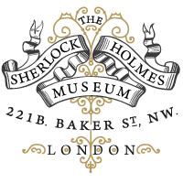
The Sherlock Holmes Museum
221b Baker Street London NW1 6XE England

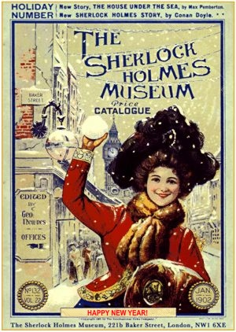

Sherlock Holmes and Doctor John H. Watson
lived at 221b Baker Street between 1881-1904, according to the stories written by Sir Arthur Conan Doyle. The house is protected by the government due to its "special architectural and historical interest", while the 1st floor study overlooking Baker Street is still faithfully maintained for posterity as it was kept in Victorian Times.
Step back in time, and when you visit London, remember to visit The World's MostFamous Address - 221b Baker Street - the Official Home of Sherlock Holmes!
Open every day of the year (except Christmas Day) from 9.30am - 6pm
Admission: Adult £10 Child £8 (under 16yrs)

